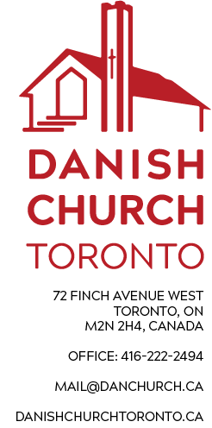
March 16, 2025
Dear Member(s),
You are invited to participate in the Annual General Meeting of this church. It will be held on Sunday April 6, 2025 after the service at approximately 12 noon. This will be both an in-person and hopefully a Zoom meeting as we want to have as much participation as possible. You are listed as a registered member(s), and are encouraged to be part of this important meeting. A Zoom link will be posted on the church website (http://www.danishchurchtoronto.ca/agm-april-6), but we do hope that if possible, you will join us in person and take part in the decisions that impact the operation of our church and congregation.
The meeting agenda is shown below, and the 2024 Financial Statements are enclosed. Minutes from last year’s AGM are available on our website, or at the church. We look forward to seeing you at the meeting.
The Board.
AGM AGENDA – April 6, 2025

- Opening of the meeting by the President, Sune Overgaard.
- Determination of Quorum.
- Approval of the Minutes from 2024 Annual General Meeting.
- The President’s Report: Sune Overgaard
- The Pastor’s Report: Kirstine Rasmussen
- Treasurer’s Report: Lisa McConnell/Sune Overgaard
- Presentation of Accountant’s comments re 2024 financial review
- 2024 Financial Statements
- Operating and Capital Budgets for 2025
- 2026 Levy payment at $20 per person
- Appointment of Accountant for 2025 Review
- Report from Outreach Director – Susanne Truelsen
- Report from Building and Maintenance Committee:
- Reports from the main Church Activity Groups:
- Bazaar: Kirstine Rasmussen
- Church Café: Liselotte Ostergaard
- Folk Dancers: Audrey Urszulan
- Golden Age Club: Lilly Nielsen
- Other Business:
- Election of Board Members:
- Ending their terms are Lisa McConnell, Sune Overgaard, Joan Skovhoj, and Susanne Truelsen. All have agreed to stand for re-election. The Board recommends these people, as well as the recent appointee Malou Kongsted, to the Board.
- Nominations from the floor
- Conclusion.

